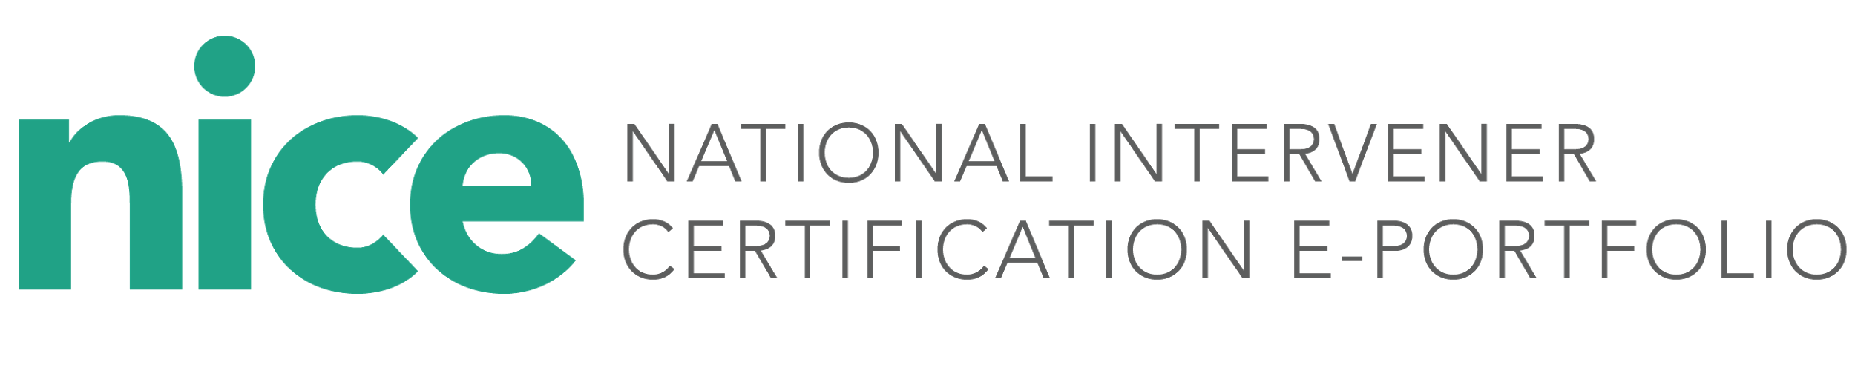
Mentor Information Form
Mentors, please complete this form and share a copy with the candidate you are mentoring and the designated state deaf-blind project or university partner.
Date:
Name:
Preferred Phone:
Email:
Preferred contact method and best time of day and days of the week to meet:
Discipline/areas of expertise:
Endorsements, licensure, certification areas (if applicable):

I want to be a mentor in the NICE process because:

To me, our mentorship relationship looks like:

Signature _____________________________ Date_______________________

